Kimberly Snyder’s Glowing Green Smoothie

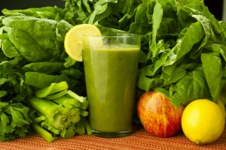
Save Print
Author: Kimberly Snyder
Recipe type: Green Smoothie
Serves: 5-6 cups
Ingredients
- 12-16 oz Filtered Water
- 1 head Romaine Lettuce
- 1 cup Spinach
- 3 Celery Stalks
- 1 Apple (cored)
- 1 Pear
- 1 Banana
- Juice ½ Lemon
- 1 cup Ice
Instructions
- Place all ingredients in the jar in order listed
- For Blendtec: Press the Soup Button
- For Vitamix: Select VARIABLE, speed #1. Turn on machine and quickly increase speed to #10; then to HIGH. Run for 1½ minutes or until smooth.
Retrieved from http://www.blenderbabes.com/all-the-rest-recipes/kimberly-snyders-glowing-green-smoothie-recipe/
Orange Julius Smoothie
1 orange
½ cup milk
½ tsp. vanilla extract
Ice
Sweetner

Blend together until smooth! Enjoy!

